Retrieving Data Using the SQL SELECT Statement
1. Determine the Structure of DEPT Table and its Contents.
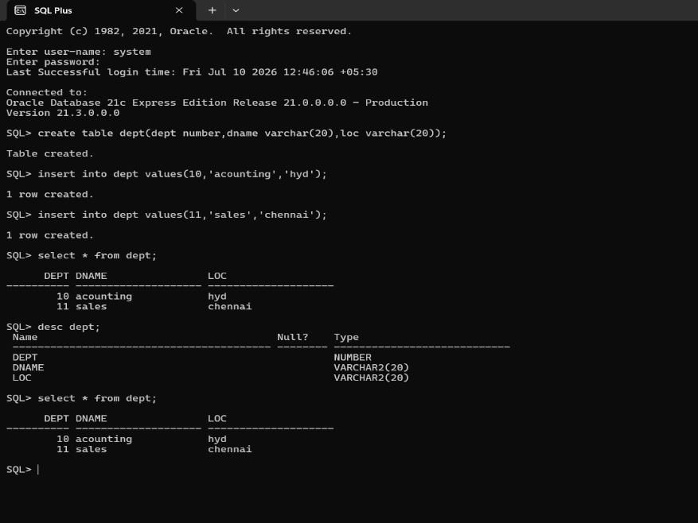
2. Determine the Structure of EMP Table and its Contents.
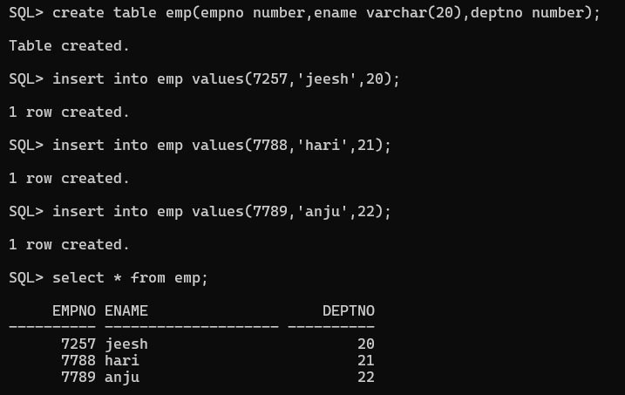
3. Display the Ename and Deptno from Emp table whose Empno is 7788.
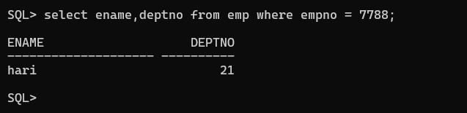

Restricting and Sorting Data
- Display the Ename,Sal,Comm from Emp table who earn commission and sort the records in descending order of Salary and Comm. Use column’s numeric position in the ORDER BY clause
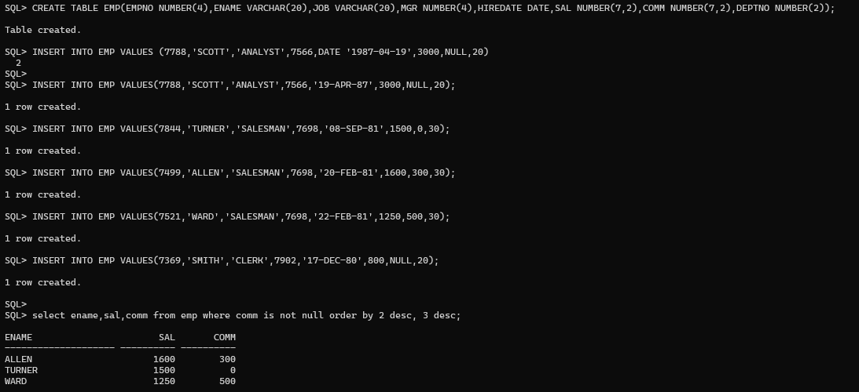
- The HR department needs a query to display all unique job codes from the EMP table.

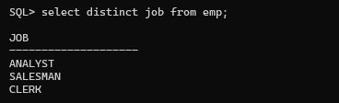

- The HR department wants more descriptive column headings for its report on employees. Name the column headings Emp #, Employee, Job, and Hire Date, respectively by giving Column Alias

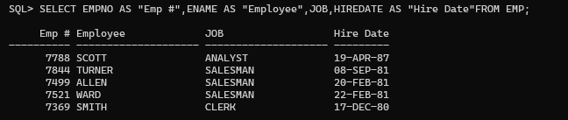

- The HR department has requested a report of all employees and their job IDs. Display the last name concatenated with the job ID (separated by a comma and space) and name the column Employee and Title by giving Column Alias.

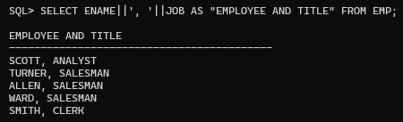
5. To familiarize yourself with the data in the EMP table, create a query to display all the data from that table. Separate each column output by a comma. ENAME,JOB,HIREDATE,MGR.Name the column title THE_OUTPUT.
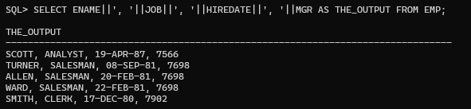
6. Create a report to display the ename, job , and Hiredate for the employees name is SCOTT or TURNER. Order the query in ascending order by hiredate.
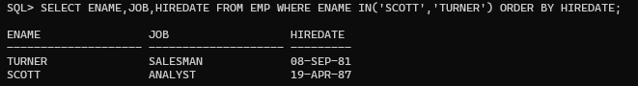
7. Display the ename and department number of all employees in departments 20 or 30 in ascending alphabetical order by ename.
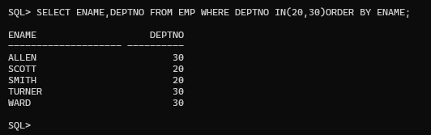
8. Modify the previous query to display the last name and salary of employees who earn between 2000 and 3000 and are in department 20 or 30. Label the columns Employee and Monthly Salary, respectively giving Column Alias
9. The HR department needs a report that displays the last name and hire date for all employees who were hired in 1981
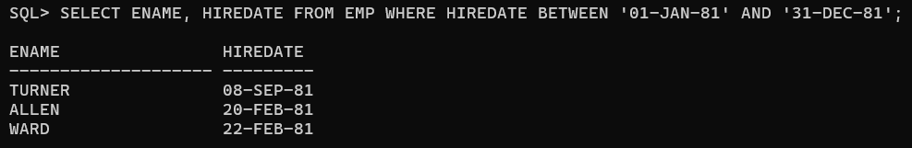
10. Display the Ename, Sal of employees who earn more than an amount the user specifies after a Prompt.
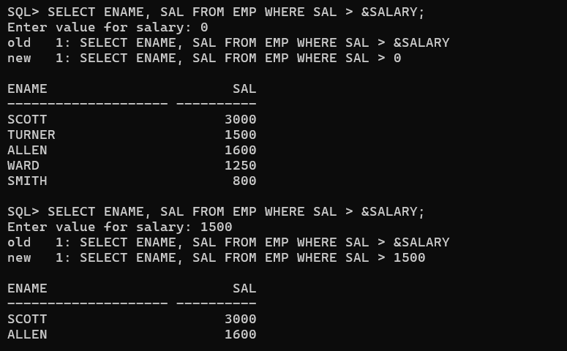
11. Create a report to display the last name and job title of all employees who do not have a manager.
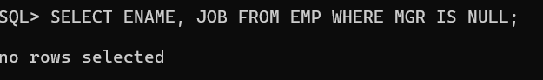
12 Create a query that prompts the user for Manager ID and generate EMPNO,ENAME, SAL,DEPTNO. The user should have the ability to sort the records on a selected Column.
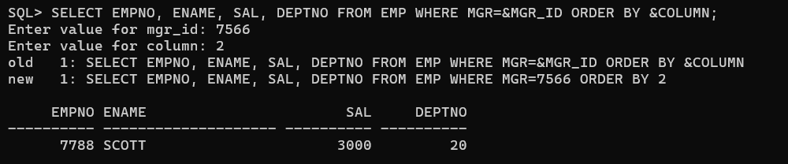
13. The HR department wants to run reports based on a manager. Create a query that prompts the user for a MGR and generates the empno, ename, salary, and department for that manager’s employees. The HR department wants the ability to sort the report on a selected column
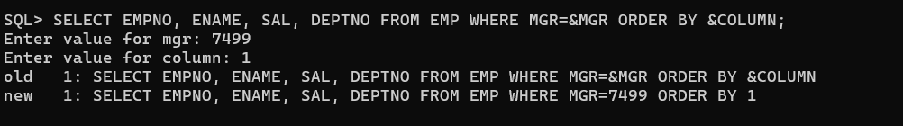
14. Display all employee last names in which the third letter of the name is A


15. Display the last name of all employees who have both an A and an S in their ename
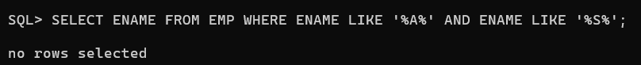
16. Display the Ename, Job, Sal for all employees whose jobs are CLERK and whose salary is in 800 or 950 or 1300.
